Pivotal PREMUP pilot – Phase 1

Growth Curve
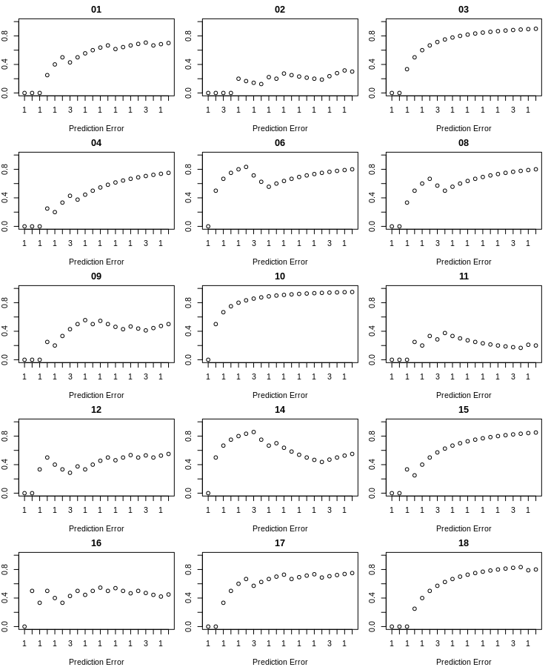
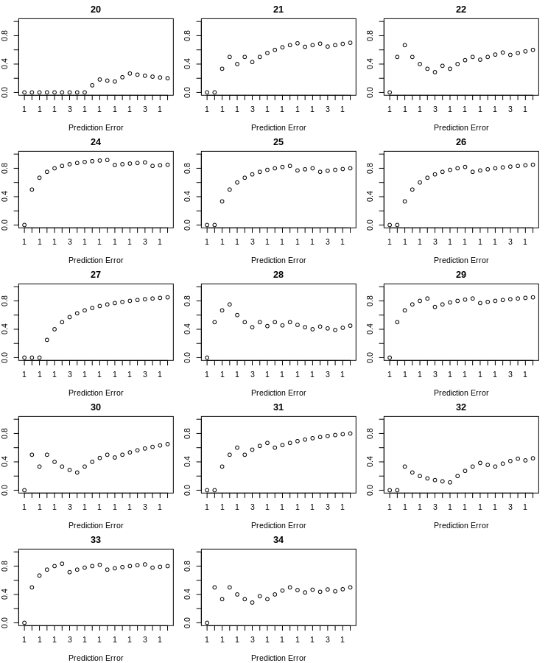

Fitting polynomic regression
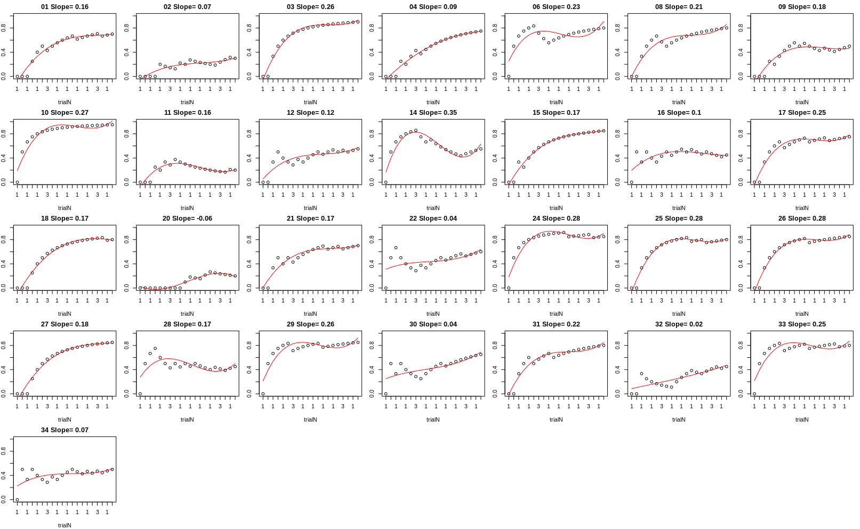

Rasmus Model
Bayes-optimal estimate of the category probabilities can be obtained using the Dirichlet-multinomial model, which can be reformulated to a delta-rule model:

This estimate is based on the current estimate of the category probabilities (θn,j (cn)) and the prediction error. The learning rate 1/n =: α indicates to which degree the prediction error influences the updated estimate of the category probabilities.
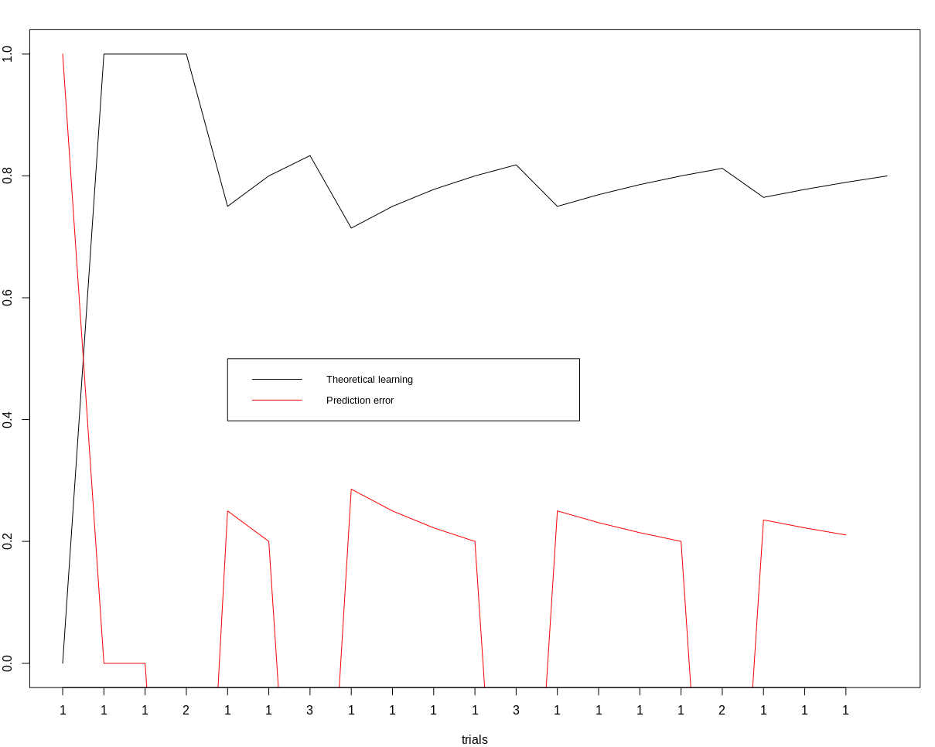
For the memory phase, the probability of remembering the item is 1/1+exp(prediction error)

Rescorla-Wagner model
ΔV = αβ(λ −ΣV ) Prediction error was estimated as λ −ΣV , where λ is the maximum degree of association (0.80) (or asymptotic level of associative strength) and ΣV is the sum of all the strenghts of the association until that trial. So in this model, the prediction error decreases with the increase of the strength of the association. Alpha is the learning rate of association of first stimulus and beta is

For lambda and learning rate fixed the relationship is the following

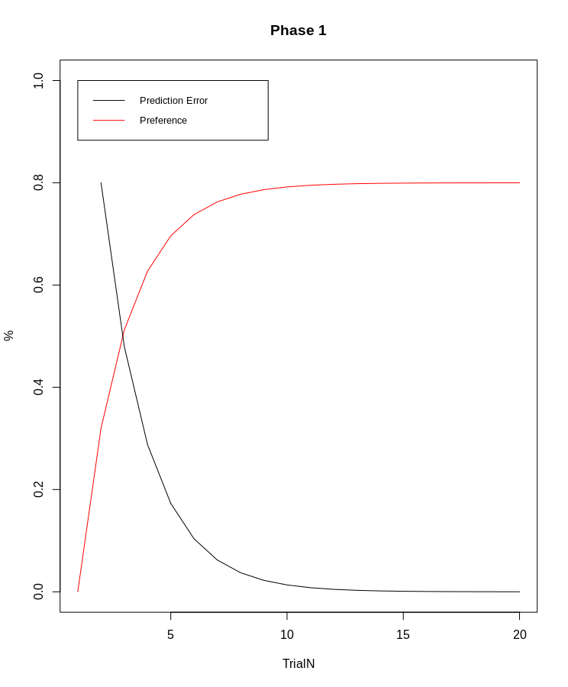

However, we have matching and unmatching trials. So, we need to specify different values for different trials. In one simulation, I assigned different values to the beta parameter, depending on whether it was 80 % or 10% contingency. In case of 10% contingency, the beta parameter was negative(-b).
In order to find the weights (alpha and beta), here we set alpha fixed to 0.30 and beta is free to vary from 0.3 up or down, for each participants. R squared is calculate for each fit. The strength is the strength of the model of the best fit. The alpha parameter detemines the learning rate: higher alpha means faster learning rate. The final assumption made by this model was that the beta, the association with the category, was negative (-x) in the case of unmatched trials. The results were the folllowing.
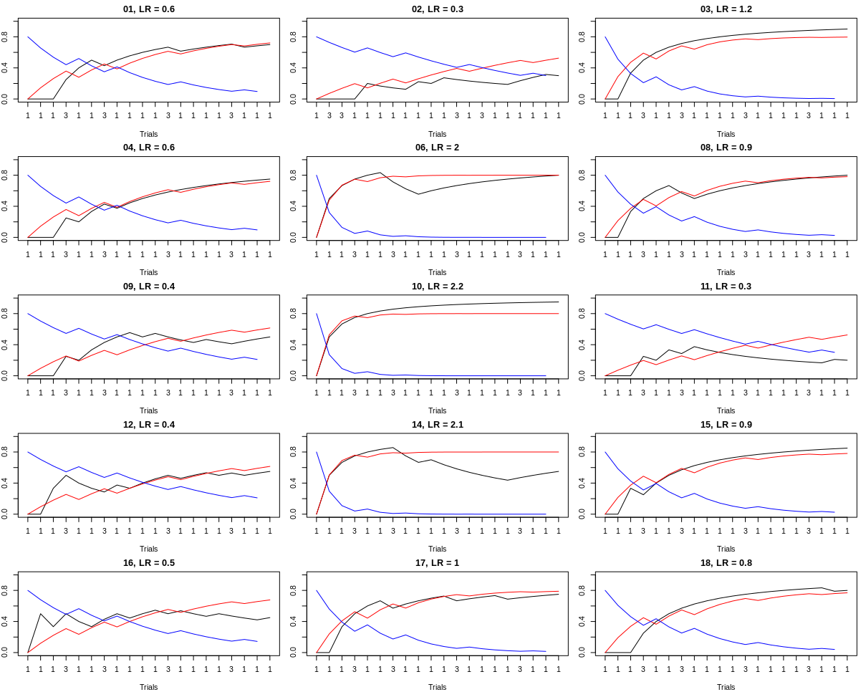
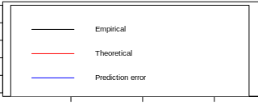

Q-learning model

This model was built after the Murray et al. (2007) paper. In this paper, Lambda was set to 1 for reinforced trials, and to 0 for unreinforced trials. In the following, Lambda was set to 0.80 and 0.10 for high and low probability categories.
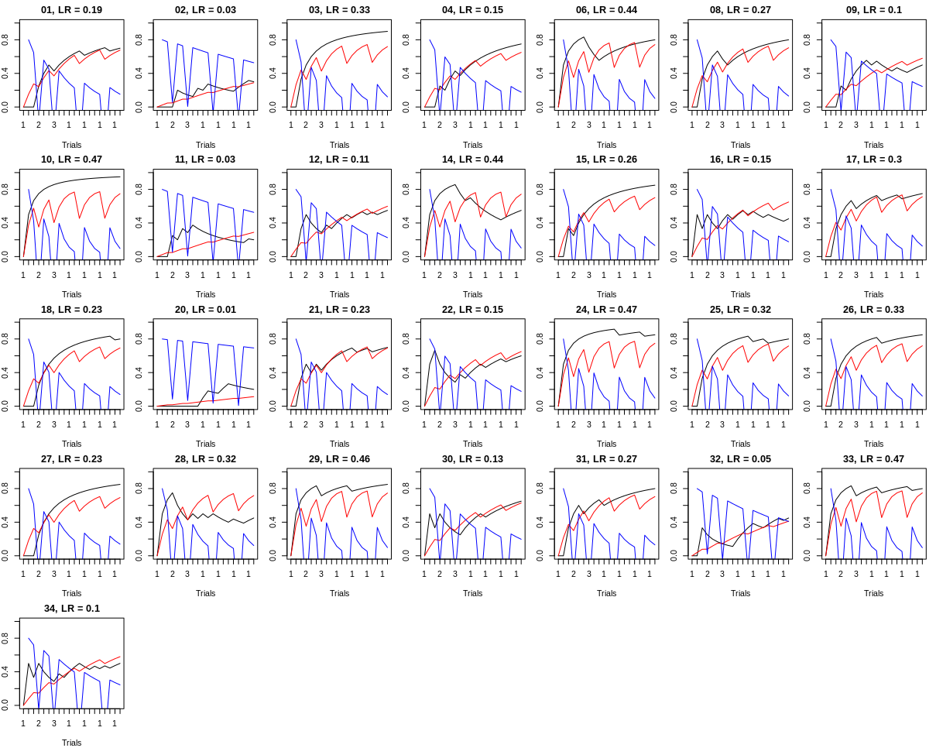

Bayesian model
As we have 3 discrete choices among object (categories), the distribution is called multinomial. The multinomial distribution is an extension of the binomial distribution to the case where there are more than 2 outcomes. In our case, the scenes are associated with the object categories with a probability mass of 0.80, 0.10, 0.10, respectively.
At each trial, we want to estimate the probability of the scene:-object association given the observed data. In Bayesian statistics, the parameter vector for a multinomial is drawn from a Dirichlet Distribution. It is the conjugate prior for the multinomial, because it is expressed in the same family distribution of the posterior: they are both counts, or pseudocounts. The Dirichlet Distribution, is charachterised by k, the number of outcomes, and alpha, a vector of positive real values called the concentration parameter. The alpha is called an hyperparameter because it is aparameter of the prior. The alpha parameter is composed by pseudocounts: they are observations of each outcome that occur before the actual data is collected.Therefore, the alpha are the prior, estimated in terms of pseudocounts. They capture our prior belief about the situation. We can set alpha at the beginning to be equal, say that alpha = [1.1.1]. If we see one of the categories associated with the scene, our alpha change, alpha = [2,1,1]. The exact value of the pseudocount reflects the level of condifence we have in our prior beliefs. Our prior can be very strong, with larger pseudocounts. In this case, they will have a greater effect on our posterior, while smaller pseudocounts will have smaller effect and will let the data dominate the posterior.
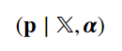

This formula shows that the probability that one scene is associated with a certain category is conditioned on the data (X) and on the hyperparameter alpha, which is our prior.

The expected value, our mean of the posterior distribution, can be espressed for a Dirichlet-Multinomial as follows:

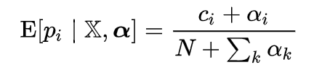

Where N is the number of the trials, c is the observed count for each category, and alpha_i is the pseudocount (hyperparameter) for each category. The alphas can be set up to 1, or the number can be incresaed, therefore adjusting the level of confidence in this prior belief.

Alpha = 1,1,1
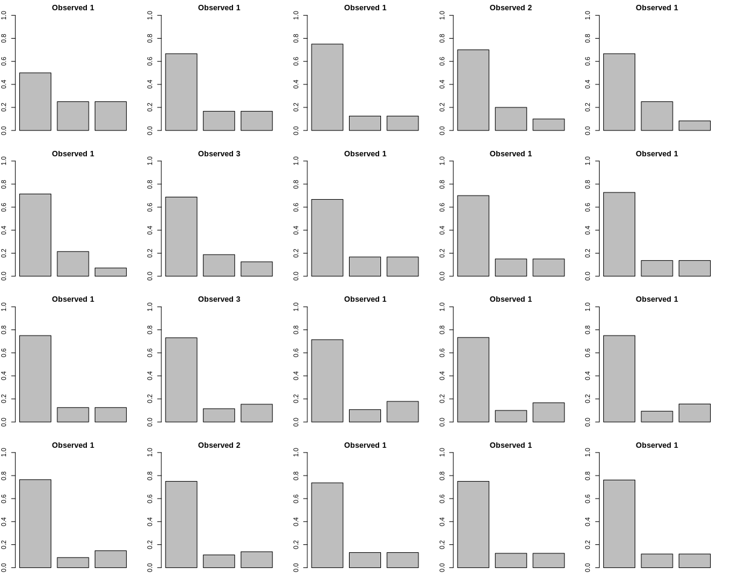
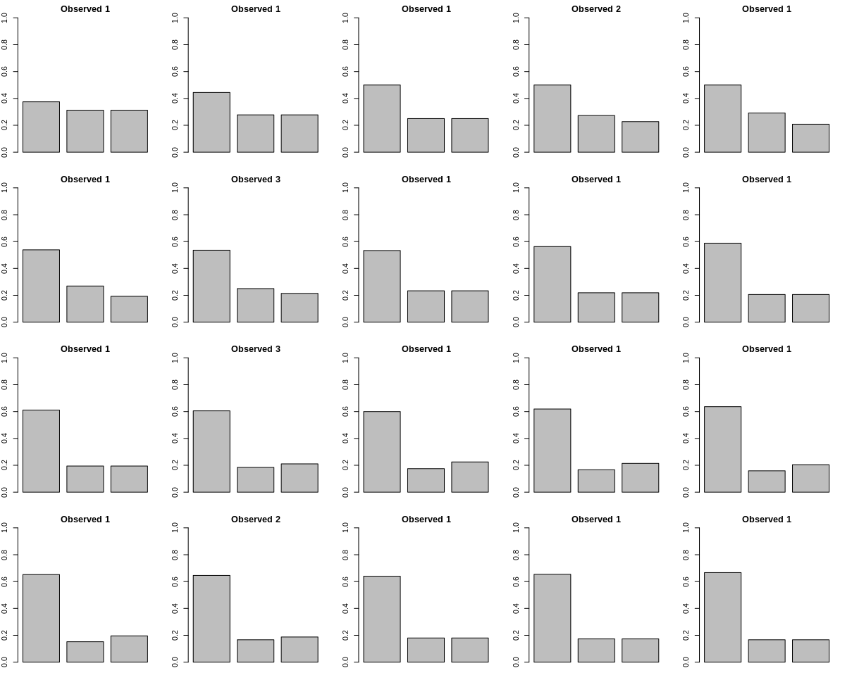
alpha=5,5,5

alpha=50,50,50
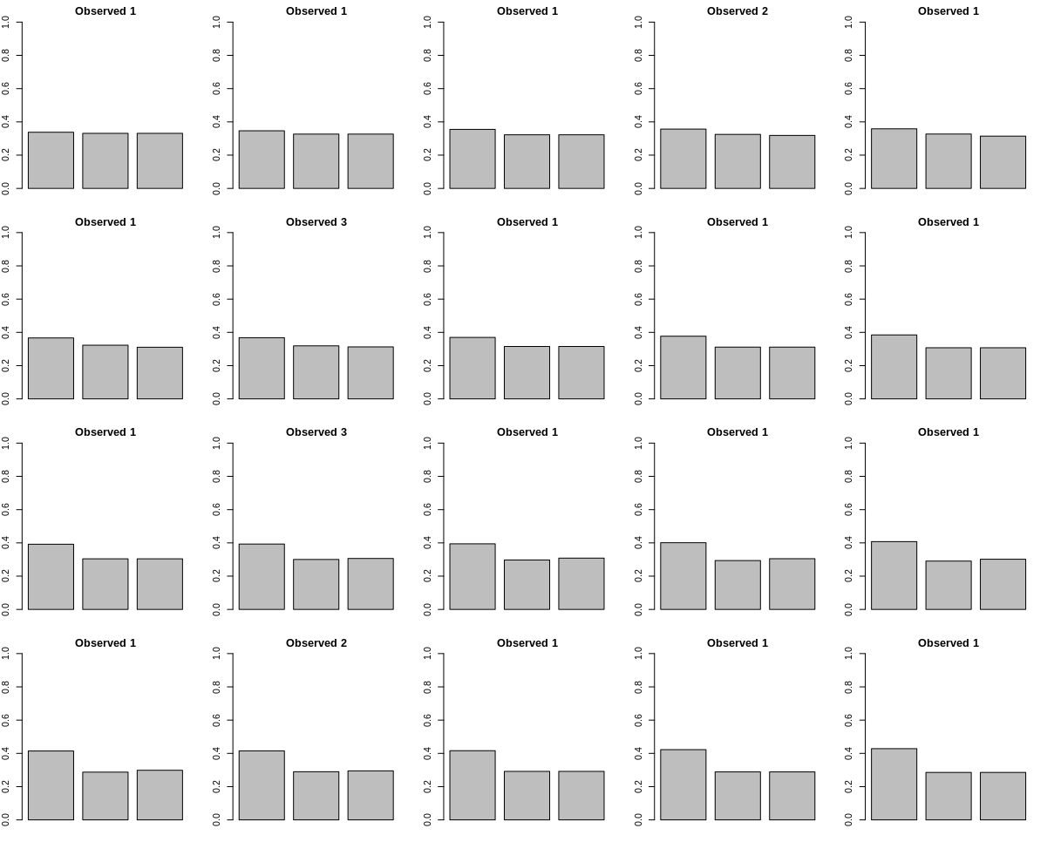
If we want to know how participants different in their alphas, namely their initial strong beliefs on the fact that the tree category differ in their association with the scene (which consequently changes the speed with which participants update their priors), we can look at how the posterior expectation, inferred by trying different alpha, differ from participants’ preference with that category. We are assuming that participans choice of a particular category increases as the posterior belief in that category increases. We can find the “posterior of best fit”, and consequently find the alpha parameter. In addition, we can estimate the prediction error for each trial, calculated as the likelihood of an event not occurring, depending on the belief of that event occurring updating trial after trial.

Reults are the following:
